Alexandra Fedorovsky
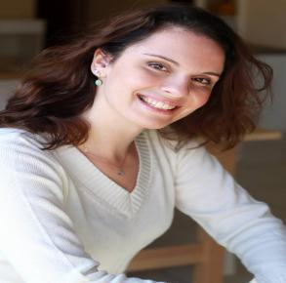

Phone: +972523818597 |Email: alexandrafedorovsky.a@gmail.com

Education:
​Bachelor's Degree in Theatre& acting, University of Haifa, Israel.
​Study abroad acting program, Univeristy of Richmond, USA.
​Chubbuck acting method, begginer+ advanced with Alon Neuman and Shahar Rozen
​Camera acting class with the director Yuval Shefferman.
Playwriting workshops with Roi Reshef Maliach
Vocal training with Naama Nachum and Katerina Petric
Television:
Night Live with Nadav Borstein- Channel 13, speaker and presenter of Dusseldorf, Germany.
Theatre:
The Invisible Thread- Mono show directed by Fiona Leonard, 24-hour Theatre Online Festival, Germany. Between USA, England, Australia and Germany.
Friday Dinner- The mother-lead, Directed by Tslil Hajaj,
Acre Festival, Hasimta Theatre, Best show award winner in Spring Festival
Butterflies in The Sunrise- Multiple roles, the play included dance, physical performance and singing. ZAGOPA Ensembale, By Idan Silberstein, Jaffa Interntional Festival
​ZAGOPA Ensamble Group-A lead actress, writer, singer. Directed by Idan Silberstein, Short monthly performances followed by parties, Hasimta Theatre.
Moments- A woman in a war, by Oleg Rodovilsky& Marina Belyavtseva,
ZERO Theatre (In Russian)
Children fairytales based plays- Snowhite, The Red riding hood, Cinderella and other lead female roles. Children productions by Maya Bahir, Zvika Buzaglo& Tali Regev
Lea Goldberg Celebration- The moon, by Yuval Cohen& Dana Dvorin, Haifa Theatre.
Film:
The invisible thread- A lead, directed by Fiona Leonard, an online film- theatre festival between Germany, USA, Canada and Australia
The Actress- Michal- lead, short film, by Sharon Shaked, Kino Festival
Inside Out- Alex-lead, short film written by me, directed by Sharon Shaked, Kino Festival
Life's like this- Gali- lead, a short film by Rotem Green, Seminar Kibbutzim College
​One Shot- The mime- lead, a short film by Yaniv Assa, Kino Festival.
​Commercial: University of Tel Aviv, Real estate brand, Consumerism image film.
Languages and special skills: English, Hebrew, Russian, Spanish, medium German.
Host, Voice over, Dubbing, Singing- Mezzo-Soprano, Guitar playing, Writer- Blogs, content writing, social media, playwriting and more. Acting coach and workshop leader.

